Healthcare Record Management System Using Blockchain

Nikhil Awatade
Computer Engineering
PICT
Pune, India

Tejas Bendkule
Computer Engineering
PICT
Pune, India
Atharva Deshmukh
Computer Engineering
PICT
Pune, India

Mrs. Rajani Jadhav
Computer Engineering
PICT
Pune, India
Atharva Walake
Computer Engineering
PICT
Pune, India

Abstract—Healthcare record management plays a pivotal role in delivering effective healthcare services, but traditional systems are beset by challenges related to data security, interoperability, and patient control. To overcome these challenges and usher in a new era of healthcare data management, blockchain technology has emerged as a transformative solution. This survey paper explores the application of blockchain in healthcare record management systems, addressing its benefits, implementation challenges, and the evolving landscape. Additionally, it delves into innovative strategies for moving beyond traditional systems, focusing on patient-centric approaches, improved interoperability, and the integration of artificial intelligence. By combining these elements, this survey paper provides insights into the potential of blockchain to revolutionize healthcare record management and inspire further research and development in this critical domain.
Keywords— Blockchain, Interoperability, Patient-Centric Approaches, Innovative Strategies.

Introduction
The effective management of healthcare records is fundamental to providing high-quality and secure healthcare services. Traditional healthcare record management systems have long been plagued by challenges that compromise data security, interoperability, and patient control. As the healthcare landscape rapidly evolves, there is an increasing demand for innovative solutions that can enhance the integrity, accessibility, and confidentiality of patient data.
Blockchain technology has emerged as a promising remedy to the long-standing shortcomings of traditional healthcare record management systems. By introducing a decentralized and tamper-proof ledger system, blockchain offers the potential to revolutionize the way healthcare records are created, stored, and shared. Its unique attributes, such as data immutability and cryptographic security, have generated considerable interest in the healthcare sector, promising a new era of digital health record management.
In this exploration, we delve into the multifaceted realm of blockchain-based healthcare record management. We aim to comprehensively explore the application of blockchain technology in this context, highlighting the advantages it brings, the challenges it confronts, and the evolving landscape of its implementation. Moreover, we turn our attention to innovative strategies for moving beyond the constraints of traditional systems, focusing on patient-centric approaches, enhancing interoperability, and the integration of artificial intelligence (AI). Together, these elements constitute a holistic view of the potential of blockchain technology to redefine healthcare record management, safeguard patient privacy, and empower individuals in the management of their own health data.
In the ever-evolving landscape of healthcare, the management of medical records stands as a cornerstone of the industry. The seamless and secure handling of patient data is not only critical for clinical decision-making but also vital in ensuring patient privacy and data integrity. Traditional healthcare record management systems, however, have struggled with a range of persistent challenges.
Issues concerning data security, interoperability, and patient control have cast a shadow over the effectiveness of traditional healthcare record management. As the digital transformation in healthcare progresses, there is a growing need for innovative solutions to address these long-standing limitations.
Blockchain technology has emerged as a transformative force in this context. It presents an alternative approach to healthcare record management that promises to revolutionize the creation, storage, and sharing of patient data. By its very nature, blockchain, with its decentralized and tamper-resistant ledger, offers a pathway to not only enhance the security of healthcare records but also empower individuals to take charge of their health information.
In this exploration, we venture into the complex world of blockchain-based healthcare record management. Our goal is to provide a comprehensive understanding of the practical application of blockchain technology in healthcare. We will delve into the advantages it brings to the healthcare landscape, the challenges it encounters, and the continuously evolving landscape of its implementation.

Literature Review
The integration of blockchain technology into healthcare record management has garnered considerable attention from researchers and practitioners alike. This interest is underpinned by the recognition of the pervasive challenges plaguing traditional healthcare record systems. Traditional systems are fraught with issues, as noted by M. Hochman in their 2018 paper, which highlights problems such as data entry burden, workflow disruptions, and limited interoperability. These challenges echo through the literature, with studies illustrating the fragmented nature of healthcare data, leading to potential safety and quality issues. A study by D. Blumenthal and C. G. Anderson in the New England Journal of Medicine underlines the critical need for enhanced data exchange and interoperability. It's within this context that blockchain emerges as a game-changing technology. The potential advantages of blockchain are well-documented, with its immutable and secure ledger ensuring data integrity and confidentiality. Several studies, including the work of Y. Fan, S. Flahiff, and T. Kucukvar, have investigated the integration of blockchain to secure patient data and streamline data exchange. Additionally, the innovative use of blockchain to grant patients greater control over their health records, as proposed by authors like A. Eichner and M. Stedman, is a prevailing theme in the literature.
[1] Paper aims to create a diagrammatic conceptual model of medical app using Blockchain technology to manage all database of patients and doctors when they have a surgery. Built based on the gap of previous models which are mostly using Blockchain in banking and finance sector. propose a simulation space conceptual models in current studies. An app on smartphone using Bitcoin in payment could be created to facilitate doctors’ management of all their patients directly and effectively as well as helping patients have a good comparison of cost, procedure or preparation of pre and post surgery.
[2] likely explores the assessment of blockchain technology adoption in the context of electronic health record (EHR) systems. The authors likely investigate the potential benefits and challenges associated with integrating blockchain into EHR management. They may examine how blockchain can enhance data security, patient control over health records, and interoperability among various healthcare providers. The study may also evaluate the practicality and feasibility of blockchain adoption in healthcare settings, considering the technical, regulatory, and ethical dimensions. Overall, it is expected that the paper provides insights into the role of blockchain in transforming EHR management systems and contributes to the understanding of this innovative approach within the healthcare sector.
[3] addresses the growing need for secure, patient-centric health information exchange in the healthcare domain. It is becoming increasingly evident that traditional health record management systems are marred by issues like data fragmentation, privacy concerns, and the lack of patient control.[3] In response to these challenges, the authors propose a novel framework that leverages blockchain technology to create a more patient-centric approach to healthcare data management. Their approach focuses on ensuring patient-controlled access to health records, consent management, and a more secure, interoperable, and efficient data exchange process. By exploring the potential of blockchain to reshape healthcare data management, this paper contributes to the ongoing discourse on the role of blockchain in revolutionizing the healthcare industry.
[4] presents a novel solution to address the security and accessibility of personal health records (PHRs) using blockchain technology. PHRs are private and vital assets for patients, but traditional systems have limitations. The authors propose the development of an Emergency Access Control Management System (EACMS) based on permissioned blockchain platforms, specifically Hyperledger Fabric and Hyperledger Composer.
[4] system introduces a secure and patient-centric approach to managing health records. It enables patients to have greater control over who can access their records in emergency situations while ensuring the integrity and privacy of the data. By leveraging blockchain's decentralized and immutable ledger, the EACMS seeks to provide a robust solution to the challenges associated with data security, sharing, and privacy in the healthcare domain. The study contributes to the growing body of research exploring the potential of blockchain technology to enhance the management of personal health records and improve emergency access control.
[5] provides an extensive and in-depth overview of the utilization of blockchain technology within the healthcare sector. The authors delve into the multifaceted applications of blockchain in healthcare, emphasizing the potential it holds to address the industry's persistent challenges. The comprehensive survey begins by acknowledging the existing issues in traditional healthcare record management, such as data security, interoperability, and patient control. It highlights the importance of finding innovative solutions to overcome these limitations as the healthcare landscape evolves.
Moreover, the work done in [5] examines the emerging trends and strategies for moving beyond traditional healthcare systems. It emphasizes patient-centric approaches, improved interoperability, and the integration of artificial intelligence (AI). These elements are collectively presented as a holistic view of how blockchain technology can redefine healthcare record management, empower patients to control their health data, and contribute to the ongoing transformation of the healthcare industry.
This research paper [6] delves into the development of a secure Electronic Health Record (EHR) system using blockchain technology. Electronic Health Records are a crucial component of modern healthcare systems, and their security and accessibility are paramount. The authors recognize the limitations of traditional EHR systems, which often struggle with issues related to data security, patient privacy, and data integrity. The author discusses the technical intricacies of implementing a blockchain-based EHR system. Each entry in the EHR is encrypted, providing an additional layer of security. Moreover, every record is timestamped and added to the blockchain's decentralized ledger, ensuring that the data remains tamper-proof. This design not only enhances data security but also guarantees that patients retain control over their health records.
[7] introduces a blockchain-based approach for secure data sharing in healthcare. In the rapidly evolving landscape of healthcare, the sharing of patient data among various stakeholders, including healthcare providers and researchers, is crucial for improving medical outcomes and advancing medical research. However, this sharing process often encounters significant challenges related to data privacy, integrity, and interoperability. The authors propose a novel solution that leverages blockchain technology to address these challenges effectively. One of the key features of this approach is the granular access control system. Patients can have control over who can access their healthcare data, and they can grant or deny access in real-time. This patient-centric approach empowers individuals to manage their own health data while safeguarding their privacy. Moreover, the paper addresses the issue of interoperability by standardizing data formats, making it easier for different healthcare providers and systems to exchange and interpret patient data consistently.
[8] delves into the applications and implications of blockchain technology in the context of health data management and its potential impact on health information technology (IT) and healthcare-related research. The paper begins by recognizing the increasing importance of secure and interoperable health data management systems in the modern healthcare landscape. The authors provide a comprehensive overview of blockchain technology's fundamental features, such as decentralization, immutability, and cryptographic security. They discuss how these features can address some of the longstanding challenges in healthcare, including data security, interoperability, and patient control over their health records. One significant aspect of the paper is its emphasis on the potential use of blockchain in health IT systems. It explores how blockchain can streamline and secure electronic health records (EHRs), making them more accessible to authorized healthcare providers while maintaining strict privacy and data ownership controls. The authors highlight how blockchain can enable the creation of a patient-centric approach to EHRs, where individuals have more control over who accesses their health data and under what conditions.
[9] explores how blockchain technology, with its decentralized and tamper-resistant ledger, can be employed to enhance data privacy and security in healthcare information systems. It discusses the mechanisms by which blockchain can protect patient records from unauthorized access, tampering, or data breaches. By utilizing cryptographic techniques and distributed ledger technology, blockchain ensures the integrity and confidentiality of healthcare data. Furthermore, the authors present real-world use cases and scenarios where blockchain can be effectively integrated into healthcare information systems to safeguard patient records. The paper also discusses the advantages and potential challenges of implementing blockchain technology in healthcare, offering a comprehensive perspective on its feasibility and benefits.
[10] leverages blockchain technology to create patient-centric health records and streamline data exchange in the healthcare sector. This framework addresses the persistent challenges of data security, interoperability, and patient control in traditional healthcare record management systems. By utilizing blockchain technology, Health Chain ensures the immutability and integrity of patient data, making it resistant to tampering and unauthorized alterations. This attribute enhances data security and builds trust in the healthcare system. The framework also addresses the issue of interoperability, which often hampers the exchange of data between different healthcare providers and systems. HealthChain introduces a standardized format for health data, creating a universal schema that facilitates consistent interpretation and exchange of patient data among various providers.
Overall, the literature underscores the pressing need for a paradigm shift in healthcare record management, with blockchain technology serving as a beacon of hope for a more secure, interoperable, and patient-centric approach.

Methodology

The implementation of the Blockchain-Backed Healthcare Passport necessitates a robust and well-structured methodology to ensure its successful deployment. This section delves into the technical intricacies and design considerations of the system, which includes creating self-sovereign health records, achieving interoperability, establishing permissioned access controls, and leveraging smart contracts for insurance claims and patient payments.

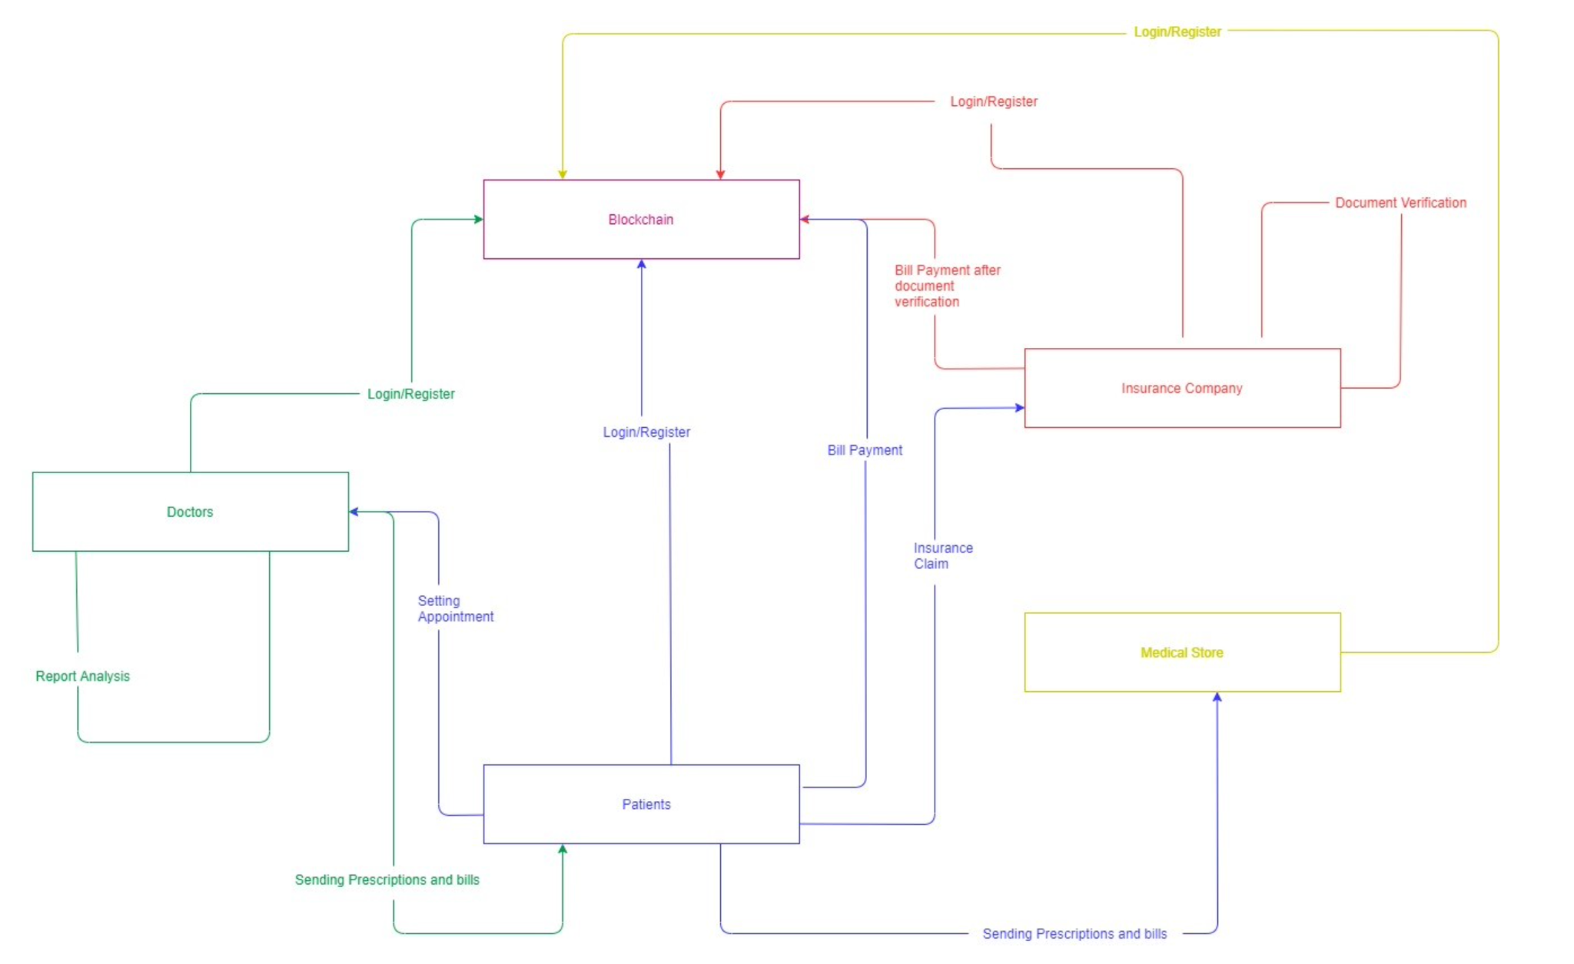

Figure 1 Communication Diagram

3.1. Self-Sovereign Health Records:
The core of the system lies in enabling patients to assert their sovereignty over their health records. To achieve this, a user-friendly blockchain-based application is developed, allowing patients to create and manage their health records securely. Each health record entry is encrypted, providing an additional layer of security, and every record is timestamped and added to the blockchain's decentralized ledger, ensuring immutability. This process ensures that the patient remains in control of their data at all times.

3.2. Achieving Interoperability:
A significant challenge in healthcare record management is the lack of interoperability among disparate healthcare systems and providers. The system addresses this challenge by establishing a standardized format for health data. It utilizes blockchain technology to create a universal schema, allowing healthcare providers and institutions to access and interpret patient data consistently. This ensures that health records can be seamlessly exchanged between different providers and systems without the need for complex data translation or integration procedures.

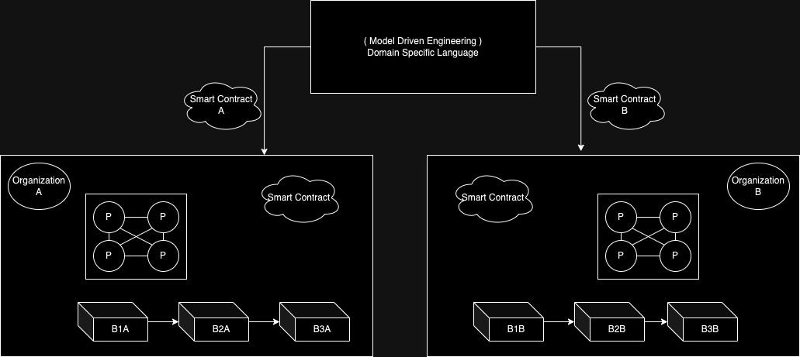

Figure 2 Architecture Diagra2 of System

3.3. Permissioned Access Controls:
The Blockchain-Backed Healthcare Passport introduces a sophisticated yet intuitive permissioned access control system.The permissions are recorded on the blockchain, ensuring transparency and accountability. Healthcare providers and authorized caregivers request access, and the patient can grant or deny access in real-time. The patient-centric approach extends to emergency access control, where individuals can designate specific emergency contacts with predefined access rights to their records in critical situations. This access control mechanism is vital to preserving patient privacy while ensuring necessary data access for healthcare delivery.

3.4. Leveraging Smart Contracts:
Smart contracts, a hallmark of blockchain technology, are employed to streamline insurance claims and patient payments. The smart contract can assess the claim, verify it against predefined criteria, and initiate the settlement process, eliminating the need for lengthy administrative procedures. Likewise, patients can make secure payments for healthcare services through the platform, using blockchain-based cryptocurrencies or tokens, reducing payment processing time and enhancing the overall patient experience.

This comprehensive methodology for implementing the Blockchain-Backed Healthcare Passport not only addresses the core features but also emphasizes user-friendliness and data security, ensuring that the patient remains at the center of their health data management. It embodies the patient-centric principles and demonstrates the capacity of blockchain technology to revolutionize healthcare record management. Figure 3 shows the architecture diagram.

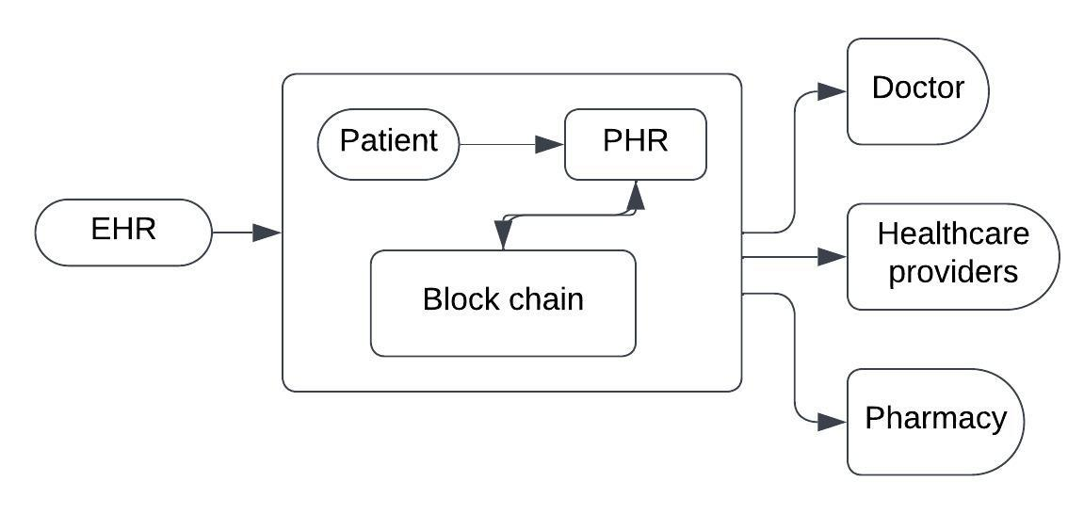
Figure. 3. Architecture Diagram1 of System

Conclusion

The integration of blockchain technology into healthcare record management presents a promising avenue for addressing the long-standing challenges of data security, interoperability, and patient control in traditional systems. This work has highlighted the transformative potential of blockchain, emphasizing its unique attributes such as data immutability and cryptographic security. By providing a holistic view of blockchain-based healthcare record management, it becomes evident that this innovative approach offers a path to revolutionize the creation, storage, and sharing of patient data. Moreover, the work has delved into innovative strategies, including patient-centric approaches, improved interoperability, and the integration of artificial intelligence, which collectively demonstrate the comprehensive impact of blockchain technology on healthcare. As we stand on the cusp of a new era in healthcare data management, it is clear that blockchain has the potential to safeguard patient privacy, empower individuals in managing their health data, and inspire further research and development in this critical domain. This exploration paves the way for a more secure, patient-centric, and efficient healthcare record management system, promising significant benefits for both healthcare providers and patients alike.

Acknowledgment

We would like to express our heartfelt gratitude to our guide, Mrs. Rajani Jadhav, for her invaluable support insightful feedback in shaping the direction and quality of this survey paper. We would also like to extend our thanks to the Computer Department of PICT (Pune Institute of Computer Technology) for providing us with the necessary resources and facilities that were essential for the successful completion of this research project. Their support and contributions have played a pivotal role in our journey to explore the transformative potential of blockchain technology in healthcare record management. We are deeply appreciative of their assistance, and their involvement has been instrumental in our research efforts. We would also like to thank all the reviewer for their valuable feedback which helped in the completion of this paper.

References
- "Blockchain in Healthcare: A New Technology Benefit for Both Patients and Doctors" by Tran Le Nguyen (2018)
- "Assessment of the Blockchain Technology Adoption for the Management of the Electronic Health Record Systems " by Saeed Alzahrani , Tugrul Daim ,Kim-Kwang Raymond Choo (2023)
- " A Patient-Centric Health Information Exchange Framework Using Blockchain Technology" by Yan Zhuang; Lincoln R. Sheets; Yin-Wu Chen; Zon-Yin Shae; Jeffrey J.P. Tsai; Chi-Ren Shyu (2020)
- " EACMS: Emergency Access Control Management System for Personal Health Record Based on Blockchain " by Ahmed Raza Rajput ,Qianmu Li ,Milad Taleby Ahvanooey ,Isma Masood (2019)
- " Blockchain in Healthcare: A Comprehensive Survey" by Juanzi Li, Qi Zhang (2020).
- " Blockchain-based Secure EHR System for Healthcare" by Wenxi Chen, Xinyu Wu (2020).
- " A Blockchain-Based Approach for Secure Data Sharing in Healthcare" by Ahmad Alabduljalil, Mohamed Elhoseny.(2020).
- "Blockchain for Health Data and Its Potential Use in Health IT and Health Care Related Research" by A. Panch and V. Gopalakrishnan (2021)
- "Enhancing Data Privacy and Security in Healthcare Information Systems Using Blockchain Technology" by R. Hassija, R. Juneja, and A. Manogaran (2021)
- "A Blockchain-Based Framework for Patient-Centric Health Records and Exchange (HealthChain)" by Benchoufi M, Ravaud P (2017)

